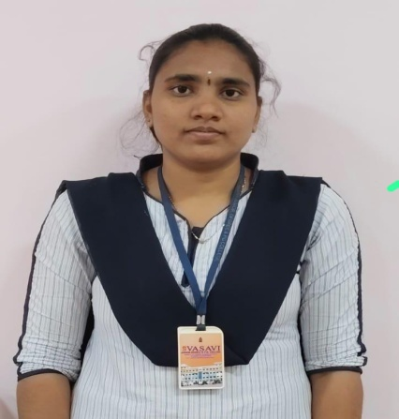
TEAM LEADER
AKULA DURGA SIVANI
Akulakumari84@gmail.com
Team id: LTVIP2026TMIDS58721

TEAM MEMBERS
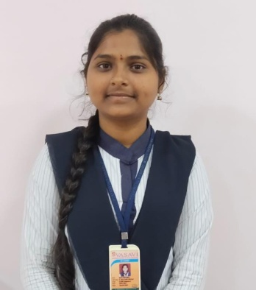

TEAM MEMBER 1
KOTA PRIYANKA
Priyankapriya78428@gmail.com
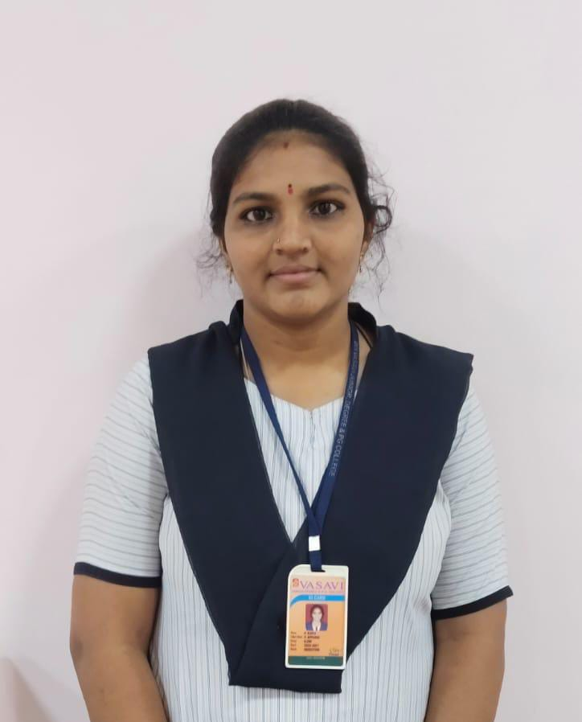
TEAM MEMBER 2
PASAM KAVYA
Kavyapasam5032@gmail.com
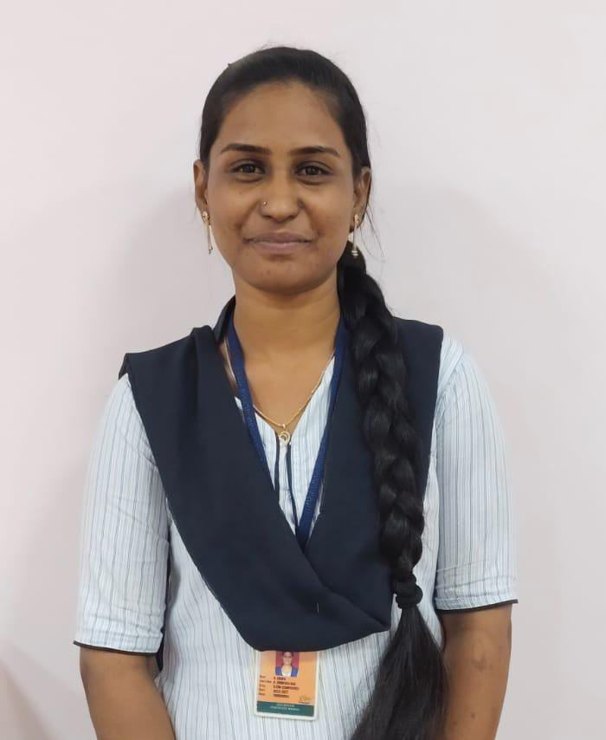
TEAM MEMBER 3
BOTTA KRUPA
Bottakrupa142@gmail.com

